# Assignment 2 – Creating an Artificial Model

## Objective

This assignment will provide you with an example on how to create geometry from scratch using PyTOUGH and learn on how to manipulate it which in this case we will learn how to refine the geometry and optimize the geometry after refinement. We will also learn how to integrate the existing topography data into the existing geometry.

## Assignment walkthrough

**Step one:** Creating the script using script 01generate_grid.py

**Step two:** Refine the model using 02RefineGrid.py

**Step three:** optimize the model using 03optimize_by_polygon.py

**Step four:** Create the .dat file and model using TIM

## How refining and optimizing Grid looks like

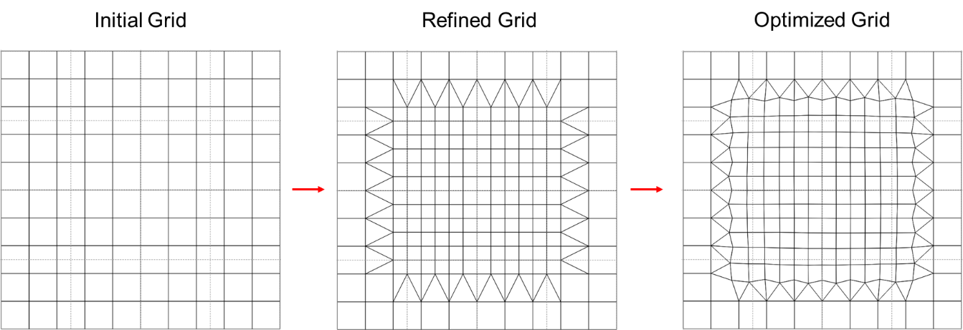

Figure 1 refined grid

## Geometry details

Use PyTOUGH provided to create this specific x,y,z layer

X = 2000m * 10

Y = 2000m * 10

Z = 1000m, 500m, 250m * 2, 125m * 4, 67.5 * 8

After you created this geometry, refine the model and optimize the model like shown in figure 1

## Perimeter for the reservoir input

T Max: 10e+14 s

Max timestep: 999

Print interval: 5

Constant Timestep: 10e+8 s

Gravity: Default

Base heat flux: 100mW/m2

## Rock type:

1. RESER: the rocktype for the rest of the model
2. INTRU: the rock type for specific block “ dr16”
3. IMPER: the rock type applied for whole layer 15

Add the GENER in INTRU with a mass flow of 10 kg/s with enthalpy of 1200 kJ/kg

## Run the Simulation

## Question

1. How is the temperature profile in the near centre of the model (e.g. dd16) compared to the block at the edge of the model (e.g. ao16)? Explain to me how we got this difference in temperature profile at the end of the simulation? (Why one have higher temperature with respect to each other)
2. According to the downhole plot, where do you think we should drill a geothermal production well and why?

***Write a short paragraph with graph based on the question that I asked!***

# Extra information regarding the downhole plot and time history plot

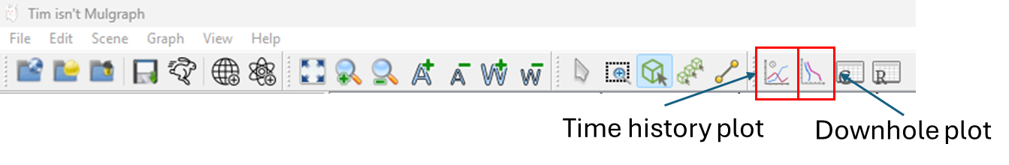

Time history plot: plot the reservoir simulation properties over the period of simulations

Downhole plot: plot the reservoir simulation properties with respect to the elevation

## How do I select the block?

